King of Bandits

**Game Loop:**

Shuffle cards

Deal cards

Pass 3 cards left (except round 4)

Player with 2 of club goes first then who ever took the last trick goes first

Round ends when every player is out of cards

Intermediate score calculated at end of round

Game ends when at least one player reaches 100

**Score:**

Heart=1 point

Queen of spades=13 points

**Hearts to King of Bandits rules translation**

**Game loop:**

Shuffle fixed number of attacks (52 attacks)

Deal attacks to players

Players choose to give up to 3 attacks to the player on their left

Round is played with 13 attack phases

Intermediate score calculated at end of round

Game ends after 6 rounds are played

Player with the most loot at the end of 6 rounds is crowned king of the bandits and ironically is sentenced to death for their crimes (Possible to have different death sentences based on amount of loot taken or could just be random)

**Score:**

Gem=1 point

Great sword (loot will be something like a crown basically the biggest piece of loot)=13 points

**Cards to Attacks translation**

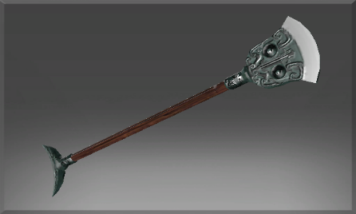Spades = Monk Spade

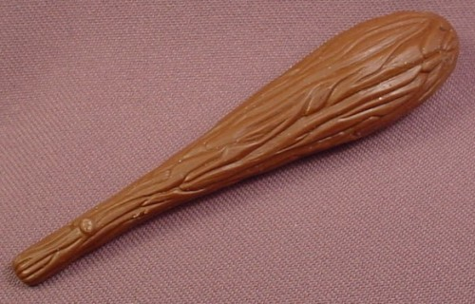

Clubs = Literal Club

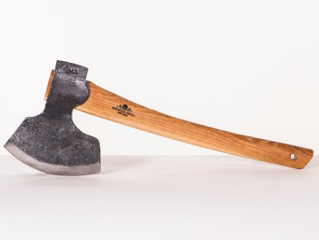Diamonds = Broad-axe

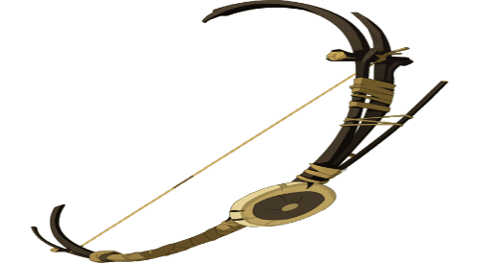Hearts = Bow

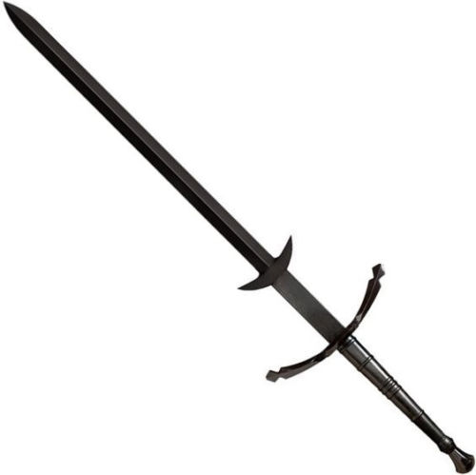Queen of spade = Great sword

**Stretch goals:**

Add “Shooting the Moon” mechanic

Add the two alternative ways to play (Omnibus and Hooligans)